Functional Specification

Created on: | 07/14/16 | Version: | 1.0
Created by: | meghana@cosyn.in | Publish Date: | 7 November 2026

1.Categories
1
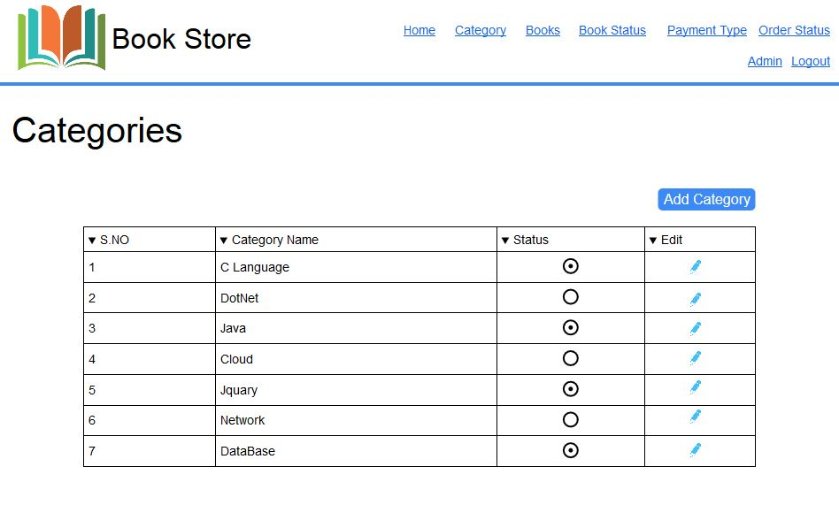
2
3
1.1 User Stories

Id | Label | User Story
1 | Table | Admin should be able to view all active or inactive categories in a table order by category name.
2 | Add Category Button | Admin should be able to add new category.
3 | Edit Button | Admin should be able to view or edit any selected category.

1.2 User Interaction Notes
Id | Label | Functional Point
1 | Table | - Admin can view all active or inactive categories in the table shown order by category name  - Columns to show in the table  - S.NO  - Category Name  - Status  - Active label in green  - Inactive label in gray  - Edit – show an icon for edit button
2 | Add Category Button | - Admin clicks on the “Add Category Button” to add new category  - Upon clicking the “Add Category” button, redirect to Add Category page so that Admin can be able to add a new category
3 | Edit Button | - Admin clicks on the “Edit” button to modify the selected category details  - Upon clicking the “Edit” button, redirect to Edit Category page so that Admin can be able to modify the category

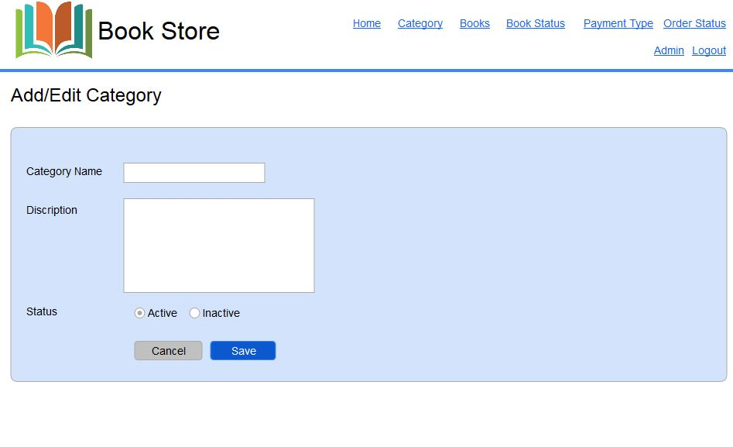
2.Add/ Edit Category
1
2

3
4
5

2.1 User Stories
Id | Label | User Story
1 | Category Name | Admin should be able to view the Category Name field with a textbox beside it.
2 | Description | Admin should be able to view the Description field with a textbox beside it.
3 | Status | Admin should be able to view the status with both Active and Inactive status  with Radio buttons.
4 | Save Button | Admin should be able to Save the category that is entered.
5 | Cancel Button | Admin should be able to cancel the category at anytime.

2.2 User Interaction Notes
Id | Label | Functional Point
1 | Category Name | - User enters Category Name  - Mandatory  - If not entered alert message “Category name is mandatory"  - Min length – 3 characters  - Length alert message – “Category name must be atleast 3 characters”  - Max length – 50 characters  - Length alert message – “Category name must be maximum of 50 characters”  - Valid characters – alphabets and space, ‘-’  - Invalid characters – numbers, other special characters  - Characters alert message – “Category name must contain alphabets and special characters [‘space’, ‘-’]”
2 | Description | - User enters Description  - Mandatory  - If not entered alert message “Description is mandatory"  - Min length – 3 characters  - Length alert message – “Description must be atleast 3 characters”  - Max length – 500 characters  - Length alert message – “Description must be maximum of 500 characters”  - Valid characters – alphabets and space  - Invalid characters – numbers, other special characters  - Characters alert message – “ Description must contain only alphabets and space”
3 | Status | - User will select the status  - Mandatory  - If not selected alert message “Status is mandatory”  - User has to select any one option from the radio buttons
4 | Save button | - Upon click of the save button  - Validate mandatory fields  - Success? If category added/updated to database, then show an alert message - “Category added/updated successfully”  - Failure? If category not added/updated, then show an alert message – “Category is not added/updated”
5 | Cancel button | - Upon click of the cancel button, Redirect the user to category list page

3.Book Status

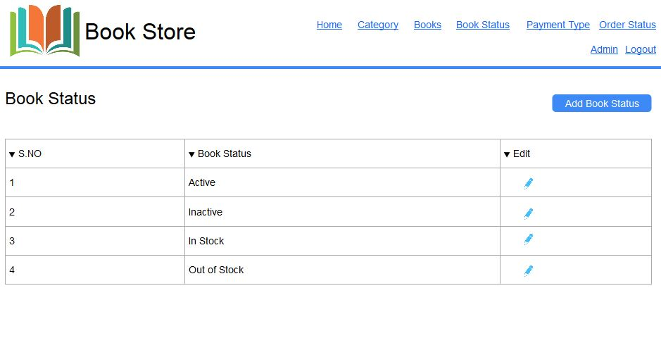
1
2
3

3.1 User Stories
Id | Label | User Story
1 | Table | Admin should be able to view all active or inactive or any other status in a table order by book status.
2 | Add Book Status Button | Admin should be able to add new book status .
3 | Edit Button | Admin should be able to view or edit any selected book status.

3.2 User Interaction Notes
Id | Label | Functional Point
1 | Table | - Admin can view all active or inactive or any other status in the table shown order by book status  - Columns to show in the table  - S.NO  - Book Status  - Edit – show an icon for edit button
2 | Add Book Status Button | - Admin clicks on the “Add Book Status Button” to add new book status  - Upon clicking the “Add Book Status” button, redirect to Add book status page so that Admin can be able to add a new book status
3 | Edit Button | - Admin clicks on the “Edit” button to modify the selected book status details  - Upon clicking the “Edit” button, redirect to Edit book status page so that Admin can be able to modify the book status

4.Add/Edit Book Status

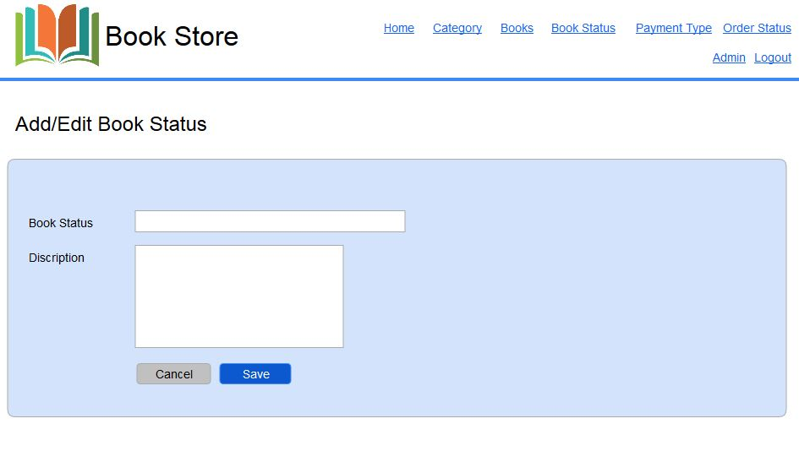
1
2
3
4

4.1 User Stories
Id | Label | User Story
1 | Book Status | Admin should be able to view the Book Status field with a textbox beside it.
2 | Description | Admin should be able to view the Description field with a textbox beside it.
3 | Save Button | Admin should be able to Save the category that is entered.
4 | Cancel Button | Admin should be able to cancel the category at anytime.

4.2 User Interaction Notes
Id | Label | Functional Point
1 | Book Status | - User enters Book Status  - Mandatory  - If not entered alert message “ Book Status is mandatory"  - Min length – 3 characters  - Length alert message – “ Book Status must be atleast 3 characters”  - Max length – 15 characters  - Length alert message – “ Book Status must be maximum of  15 characters”  - Valid characters – alphabets and space  - Invalid characters – numbers, other special characters  - Characters alert message – “ Book status must contain only alphabets and space”
2 | Description | - User enters Description.  - Mandatory  - If not entered alert message “Description is mandatory"  - Min length – 3 characters  - Length alert message – “ Description must be atleast 3 characters”  - Max length – 500 characters  - Length alert message – “ Description must be maximum of 500 characters”  - Valid characters – alphabets and space  - Invalid characters – numbers, other special characters  - Characters alert message – “ Description must contain only alphabets and space”
3 | Save Button | - Upon click of the save button  - Alert message “ Book Status added Successfully”
4 | Cancel Button | - Upon click of the cancel button, Redirect the user to book status list page

5.Books

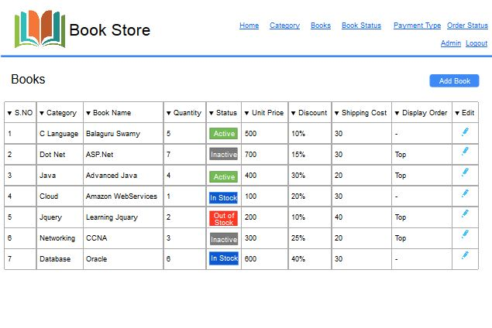
3
1
2

5.1 User Stories
Id | Label | User Story
1 | Table | Admin should be able to view all active or inactive or any other status in a table order by Category.
2 | Add Book | Admin should be able to add new book.
3 | Status | Admin should be able to view status of any selected book.

5.2 User Interaction Notes
Id | Label | Functional Point
1 | Table | - User can view all active or inactive or any other status in the table shown order by category  - Columns to show in the table  - S.NO  - Category  - Book Name  - Quantity  - Status  - Unit Price  - Discount  - Shipping Cost  - Display order  - Edit – show an icon for edit button
2 | Add Book | - User clicks on the “Add Book” to add new book  - Upon clicking the “Add Book” button, redirect to Add book page so that Admin can be able to add a new book
3 | Status | - User can view the status of books for each category  - Active in green – items are available for user  - Inactive in grey – items are visible to user but the user cannot access them  - Instock in blue – items are available for user  - Out of Stock in red – items are not available

6.Add/Edit Book

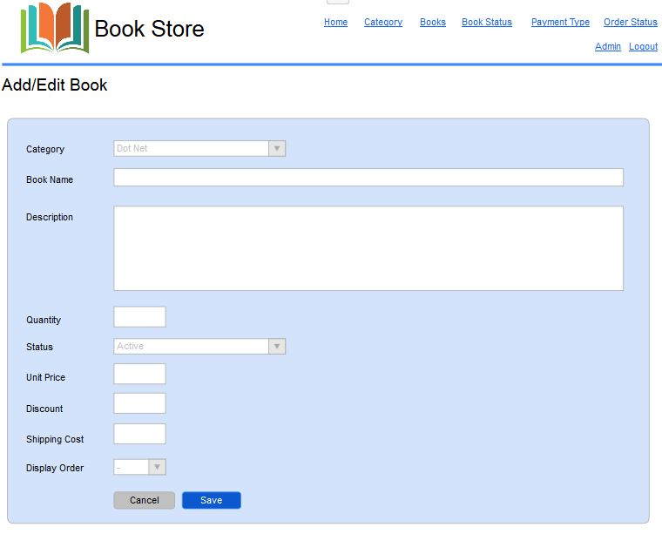
1
4
6
7
5
2
8
3
9
11

10

6.1 User Stories
Id | Label | User Story
1 | Category | Admin can view or edit the category.
2 | Book Name | Admin can view or edit the book name.
3 | Description | Admin can view or edit the description.
4 | Quantity | Admin can view or edit the Quantity of the book.
5 | Status | Admin can select the status of the book.
6 | Unit Price | Admin can view or edit the unit price of the book.
7 | Discount | Admin can enter the discount for a particular book.
8 | Shipping Cost | Admin can view or edit the sipping cost of the product.
9 | Display Order | Admin can view or edit the order that is being displayed.
10 | Save Button | Admin should be able to Save the book that is entered.
11 | Cancel Button | Admin should be able to cancel the book at anytime.

6.2 User Interaction Notes
Id | Label | Functional Point
1 | Category | - User selects category  - Mandatory  - If not selected alert message “ Category is mandatory"
2 | Book Name | - User enters Book Name  - Mandatory  - If not entered alert message “ Book Name is mandatory"  - Min length – 3 characters  - Length alert message – “ Book Name must be atleast 3 characters”  - Max length – 50 characters  - Length alert message – “ Book Name must be maximum of 50 characters”  - Valid characters – alphabets and space  - Invalid characters – numbers, other special characters  - Characters alert message – “ Book name must contain only alphabets and space”
3 | Description | - User enters Description  - Mandatory  - If not entered alert message “ Description is mandatory"  - Min length – 3 characters  - Length alert message – “ Description must be atleast 3 characters”  - Max length – 500 characters  - Length alert message – “ Description must be maximum of 500 characters”  - Valid characters – alphabets and space  - Invalid characters – numbers, other special characters  - Characters alert message – “ Description must contain only alphabets and space”
4 | Quantity | - User enters Quantity  - Mandatory  - If not entered alert message “ Quantity is mandatory"  - Valid characters – numbers  - Characters alert message – “ Quantity must contain only digits”  - Invalid characters – alphabets ,space,other special characters
5 | Status | - User has to select Status  - Active or Inactive  - Mandatory  - If not selected alert message “ Status is mandatory"
6 | Unit Price | - User has to enter Unit Price  - Mandatory  - If not entered alert message “ Unit Price is mandatory"  - Valid characters – numbers,'.'  - min length - 2 characters  - Length alert message – “ Unit price must be atleast 2 characters”  - Max length – 12 characters  - Length alert message – “ Unit price must be maximum of 12 characters”  - Invalid characters – alphabets ,space,other special characters
7 | Discount | - Users has to enter Discount  - Not Mandatory  - If discount is entered  - Max length – 12 characters  - Length alert message – “ Discount must be maximum 12 characters in length”  - Valid characters – numbers  - Invalid characters – alphabets ,space,other special characters
8 | Shipping Cost | - User has to enter Shipping Cost  - Mandatory  - If not entered alert message “ Shipping Cost is mandatory"  - Max length – 12 characters  - Length alert message – “ Shipping Cost must be maximum 12 characters in length”  - Valid characters – numbers  - Invalid characters – alphabets ,space,other special characters
9 | Display Order | - Users selects Display Order  - Mandatory  - If not entered alert message “ Display Order is mandatory"  - Valid characters – [0,1]  - Invalid characters – alphabets ,other numbers,space,other special characters
10 | Save Button | - Upon click of the save button  - Alert message “ Book is added Successfully”
11 | Cancel Button | - Upon click of the cancel button, Redirect the user to book list page

7.Homepage
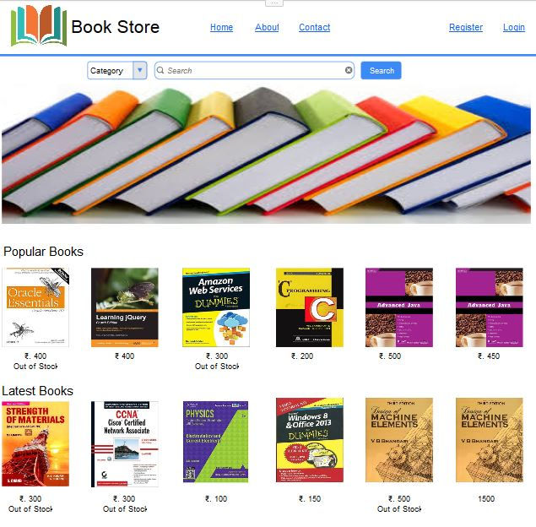
3
1
4
2

7.1 User Stories
Id | Label | User Story
1 | Menu | Non-logged in user should be able to view the menu items that are displayed in home page.
2 | Search | Non-logged in user should be able to view the search box for both category and books.
3 | Image | Non-logged in user should be able to view image in home page.
4 | Book Details | Non-logged in user should be able to view books available that are displayed in home page.

7.2 User Interaction Notes
Id | Label | Functional Point
1 | Menu | - User can access the following menu items  - Home - which directs the user to home page  - About Us - which directs the user to about us page  - Contact Us - which directs the user to contact us page  - Register – which directs the user to registration page  - Login – which directs the user to login page
2 | Search | - User can select the category from the category dropdown  - User can search the books from the search box based on the selected category
3 | Image | - User will be able to view the images in the home page
4 | Book Details | - User will be able to view the books available in home page  - User can click on the images of the books in home page and when the user clicks on the image the user is redirected to a new page containing the book details

8.Search Results

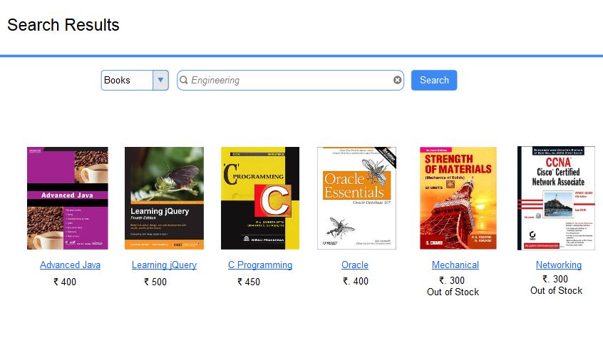
1
2
3

8.1 User Stories
Id | Label | User Story
1 | Books | Non-logged in user should be able to view the books search category in the search page.
2 | Search | Non-logged in user should be able to view the search box in the search page.
3 | Image | Non-logged in user should be able to view books related to the search criteria.

8.2 User Interaction Notes
Id | Label | Functional Point
1 | Books | - User can access books category based on search criteria  - User can access or select the type of book from the available book list
2 | Search | - User can access the search box  - User can enter any text to obtain the results  - User can get results based on the search criteria
3 | Image | - User will be able to view the books that are result of the search made  - User can access the books that are visible which are obtained depending upon the search criteria

9.Book Information
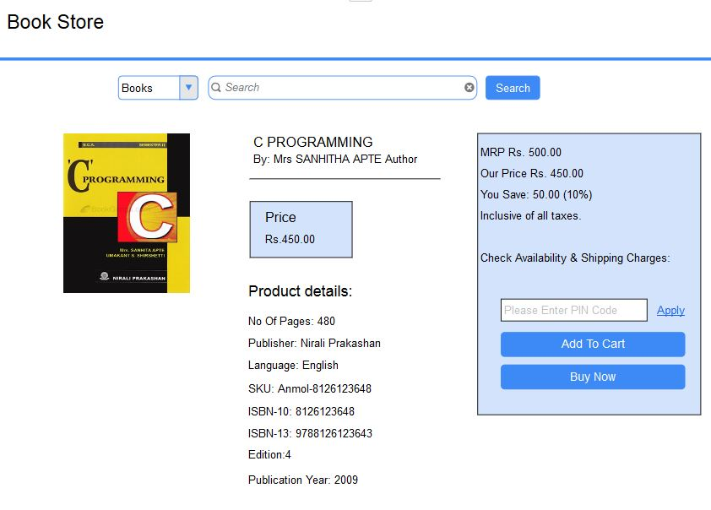
1
2
3
4

9.1 User Stories
Id | Label | User Story
1 | Books | Non-logged in user should be able to select book category.
2 | Search | Non-logged in user should be able to search the books.
3 | Book Details | Non-logged in user should be able to view books available and details for the book in search page.
4 | Payment Details | Non-logged in user should be able to view the payment details of the book.

9.2 User Interaction Notes
Id | Label | Functional Point
1 | Books | - User can access books category based on search criteria  - User can access or select the type of book from the available book list
2 | Search | - User can access the search box  - User can enter any text to obtain the results  - User can get results based on the search criteria
3 | Book Details | - User will be able to view the books details  - User can click on the images of the books in home page and when the user clicks on the image the user is redirected to a new page containing the book details
4 | Payment Details | - User should be able to view the payment details of the book  - Non-logged user can”t Process to pay the payment

10.Payment Type
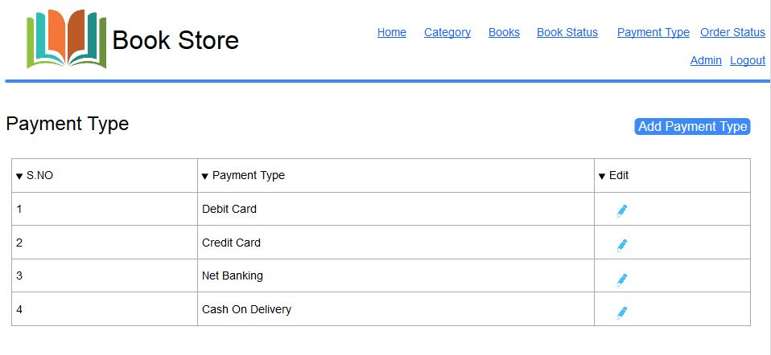
2
1
2
3

10.1 User Stories
Id | Label | User Story
1 | Table | Admin should be able to view all payment types in a table order by payment type.
2 | Add Payment Type | Admin should be able to add new payment type.
3 | Edit Button | Admin should be able to view or edit any selected payment type.

10.2 User Interaction Notes
Id | Label | Functional Point
1 | Table | - Admin can view all payment types in the table shown order by payment type  - Columns to show in the table  - S.NO  - Payment Type  - Edit – show an icon for edit button
2 | Add Payment Type | - Admin clicks on the “Add Payment Type Button” to add new payment type  - Upon clicking the “Add Payment Type ” button, redirect to Add payment type page so that Admin can be able to add a new payment type
3 | Edit Button | - Admin clicks on the “Edit” button to modify the selected payment type details  - Upon clicking the “Edit” button, redirect to Edit paymenttype page so that Admin can be able to modify the payment type

11.Add/Edit Payment Type
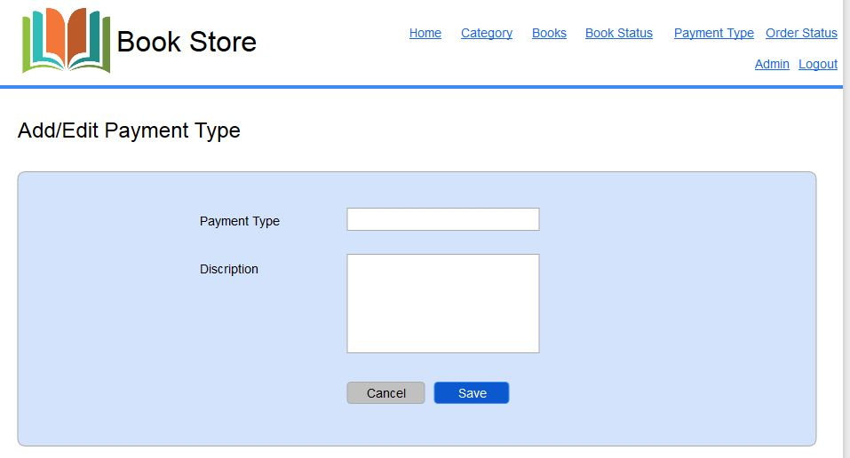
2
1
2
3
4

11.1 User Stories
Id | Label | User Story
1 | Payment Type | Admin should be able to view the Payment Type field with a textbox beside it.
2 | Description | Admin should be able to view the Description field with a textbox beside it.
3 | Save Button | Admin should be able to Save the paymenttype that is entered.
4 | Cancel button | Admin should be able to cancel the paymenttype at anytime.

11.2 User Interaction Notes
Id | Label | Functional Point
1 | Payment Type | - User enters Payment Type  - Mandatory  - If not entered alert message “ Payment Type is mandatory"  - Min length – 3 characters  - Length alert message – “ Payment Type must be atleast 3 characters”  - Max length – 25 characters  - Length alert message – “ Payment Type must be maximum of 25 characters”  - Valid characters – alphabets and space  - Invalid characters – numbers, other special characters  - Characters alert message – “ Payment Type must contain only alphabets and space”
2 | Description | - User enters Description  - Mandatory  - If not entered alert message “Description is mandatory"  - Min length – 3 characters  - Length alert message – “ Description must be atleast 3 characters in length”  - Max length – 500 characters  - Length alert message – “ Description must be maximum 500 characters in length”  - Valid characters – alphabets and space  - Invalid characters – numbers, other special characters  - Characters alert message – “ Description must contain only alphabets and space”
3 | Save Button | - Upon click of the save button  - Alert message “ Payment Type added Successfully”
4 | Cancel Button | - Upon click of the cancel button, Redirect the user to payment list page

12.Order Status
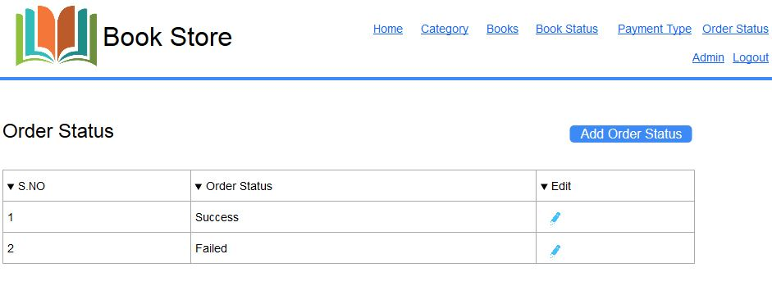
2
1
2
3

12.1 User Stories
Id | Label | User Story
1 | Table | Admin should be able to view all order status in a table order by order status.
2 | Add Order Status | Admin should be able to add new order status.
3 | Edit Button | Admin should be able to view or edit any selected order status.

12.2 User Interaction Notes
Id | Label | Functional Point
1 | Table | - Admin can view all order status in the table shown order by order status  - Columns to show in the table  - S.NO  - Order Status  - Edit – show an icon for edit button
2 | Add Order Status | - Admin clicks on the “Add Order Status Button” to add new order status  - Upon clicking the “Add Order Status ” button, redirect to Add order status page so that Admin can be able to add a new order status
3 | Edit Button | - Admin clicks on the “Edit” button to modify the selected order status details  - Upon clicking the “Edit” button, redirect to Edit orderstatus page so that Admin can be able to modify the order status

13.Add/Edit Order Status

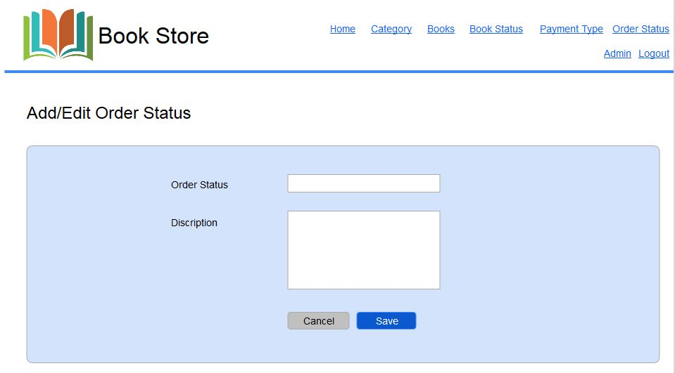
2
1
2
3
4

13.1 User Stories
Id | Label | User Story
1 | Order Status | Admin should be able to view the Order Status field with a textbox beside it.
2 | Description | Admin should be able to view the Description field with a textbox beside it.
3 | Save button | Admin should be able to Save the orderstatus that is entered.
4 | Cancel Button | Admin should be able to cancel the orderstatus anytime.

13.2 User Interaction Notes
Id | Label | Functional Point
1 | Order Status | - User enters Order Status  - Mandatory  - If not entered alert message “ Order Status is mandatory"  - Min length – 3 characters  - Length alert message – “ Order Status must be atleast 3 characters”  - Max length – 10 characters  - Length alert message – “ Order Status must be maximum of 10 characters”  - Valid characters – alphabets and space  - Invalid characters – numbers, other special characters  - Characters alert message – “ Order Status must contain only alphabets and space”
2 | Description | - User enters Description  - Mandatory  - If not entered alert message “Description is mandatory"  - Min length -3 characters  - Length alert message – “ Description must be atleast 3 characters”  - Max length – 500 characters  - Length alert message – “ Description must be maximum of 500 characters”  - Valid characters – alphabets and space  - Invalid characters – numbers, other special characters  - Characters alert message – “ Description must contain only alphabets and space”
3 | Save button | - Upon click of the save button  - Alert message “ Order Status added Successfully”
4 | Cancel Button | - Upon click of the cancel button, Redirect the user to order status list page

14.Create Account
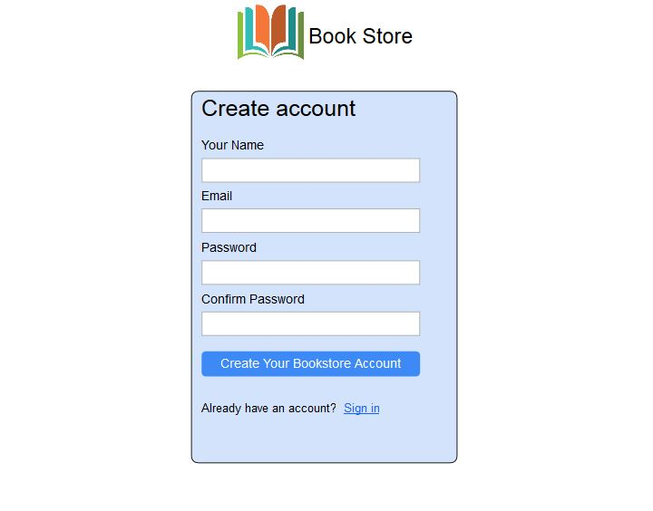
1
2
3
4
5
6

14.1 User Stories
Id | Label | User Story
1 | Name | Non-logged in user or logged in user should be able to enter the first name of the user
2 | Email | Non-logged in user or logged in user should be able to enter the email id of the user
3 | Password | Non-logged in user or logged user should be able to enter the password of the user
4 | Conform Password | Non-logged in user or logged user should be able to conform the password of the user
5 | New Account | Non-logged in user after entering all the details should click on “Create your book store account” to create a new account.
6 | Sign In | Non-logged in user can click on Sign In if the user already have an account.

14.2 User Interaction Notes
Id | Label | Functional Point
1 | Name | - Non-logged in user or logged in user enters the first name of the user  - Validations to be done  - Mandatory  - If not entered alert message – “First name is mandatory”  - Default text – “Enter your first name”  - Min length – 3 characters  - Length alert message – “First name must be atleast 3 characters”  - Max length – 20 characters  - Length alert message – “First name must be maximum of 20 characters”  - Valid characters – alphabets and space  - Invalid characters – numbers, other special characters  - Characters alert message – “First name must contain only alphabets and space”
2 | Email | - Non-logged in user or logged in user enters the email address of the user  - Validations to be done  - Mandatory  - If not entered alert message – “Email id is mandatory”  - Default text – “Enter your email id”  - If not valid alert message – “Enter valid email id”  - Max length – 255 characters  - Length alert message – “Email must be maximum of 255 characters”
3 | Password | - The system will follow the following password policy  - A minimum of 8 characters and maximum of 15 characters which is made up of the following  - At least one number  - At least one uppercase character  - At least one special character  - Length alert message – “Password must be atleast 8 characters”  - Length alert message – “Password must be maximum of 15 characters”  - Validations to be done  - Mandatory  - If not entered alert message – “Password is mandatory”  - Default text – “Enter your password”
4 | Conform Password | - The user has to enter the same password as above following the conditions in order to create the new account for book store
5 | New Account | - After the user enters all the details for creating a new account the user has to click on the “Create your book Store Account”  - Then the user is created with a login so that the user can access bookstore
6 | Sign In | - If the user already have an account then the user can click on “Sign In”  - Then the user is redirected to login page

15.Sign in

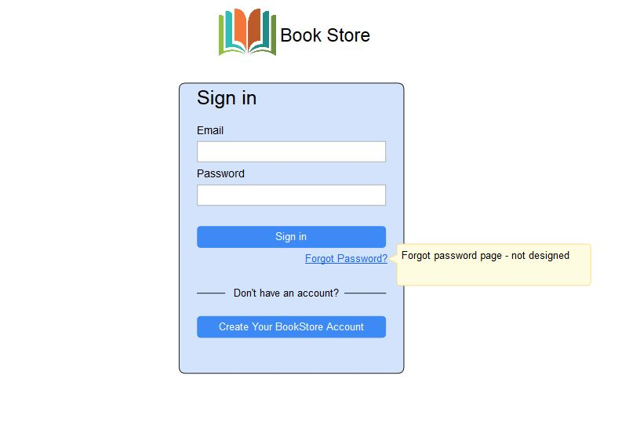
3
1
2
5
4

15.1 User Stories
Id | Label | User Story
1 | Email | Non-logged in user should be able to get access to the system by entering Email id
2 | Password | Non-logged in user should be able to get access to the system by entering his password
3 | Sign In Button | Non-logged in user should be able get access to the system after entering his correct email id and password and clicking ‘Login’ button
4 | Forgot Password? | Non-logged in user should be able to request for a password reset if he does not remember his password
5 | Create Book Store Account | Non-logged in user should be able to get access to create a new book store  account

15.2 User Interaction Notes
Id | Label | Functional Point
1 | Email | - User enters their email address  - Text entered will be forced lowercase  - Validations to be done  - Mandatory  - If not entered alert message – “Email id is mandatory”  - Default text – “Enter your email id”  - Valid Email id  - If not valid alert message – “Enter a valid email id”  - Max length – 255 characters  - Length alert message – “Email must be maximum of 255 characters”
2 | Password | - The system will follow the following password policy  - A minimum of 8 characters and maximum of 15 characters which is made up of the following  - At least one number.  - At least one uppercase character  - At least one special character  - Length alert message – “Password must be atleast 8 characters”  - Length alert message – “Password must be maximum of 15 characters”  - Validations to be done  - Mandatory  - If not entered alert message – “Password is mandatory”  - Default text – “Enter your password”
3 | Login Button | - Upon click of the login button, if authentication is successful, the user is redirected to the dashboard  - If authentication is not successful,  - Then an error message is displayed – “Incorrect Username and/or Password”  - If account is locked out,  - Then, redirect the user to Lockout page  - If account email is not confirmed,  - Then an error message is displayed – “You have not yet verified your e-mail address”
4 | Forgot Password? Link | - Clicking the forgot password link, redirects the user to the request password reset page – see Request Password below  - The encrypted password link sent to the user will be valid for a period of 48 hours from the time the email is triggered and sent
5 | Create new Book Store Account | - Clicking on the create new book store account,redirects the user to the registration page,  - the user has to fill all the details in the registration page in order to get access to the system

16.My Profile

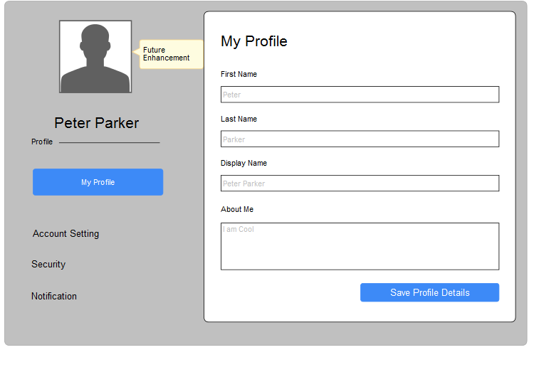
1
2

3

4

5

6

16.1 User Stories
Id | Label | User Story
1 | Profile Settings | Logged in user should be able to view the profile setting options.
2 | First Name | Logged in user should be able to enter the first name of the user
3 | Last Name | Logged in user should be able to enter the last name of the user
4 | Display Name | Logged in user should be able to enter the display name of the user
5 | About Me | Logged in user should be able to enter the about me of the user
6 | Save Profile Details | Logged in user should be able to submit a request for user profile after entering user information above

16.2 User Interaction Notes
Id | Label | Functional Point
1 | Profile settings | - Logged In user can access profile settings option which include  - Account Setting – can modify the settings of the account  - Security – user can change password for security pur-  pose  - Notifications – user can get the remainders or notifications  about the bookstore or about the account
2 | First name | - Logged in user enters the first name of the user  - Validations to be done  - Mandatory  - If not entered alert message – “First name is mandatory”  - Default text – “Enter your first name”  - Min length – 3 characters  - Length alert message – “First name must be atleast 3 characters”  - Max length – 20 characters  - Length alert message – “First name must be maximum of 20 characters”  - Valid characters – alphabets and space  - Invalid characters – numbers, other special characters  - Characters alert message – “First name must contain only alphabets and space”
3 | Last Name | - Logged in user enters the last name of the user  - Validations to be done  - Mandatory  - If not entered alert message – “Last name is mandatory”  - Default text – “Enter your last name”  - Min length – 3 characters  - Length alert message – “Last name must be atleast 3 characters”  - Max length – 20 characters  - Length alert message – “Last name must be maximum of 20 characters”  - Valid characters – alphabets and space  - Invalid characters – numbers, other special characters  - Characters alert message – “Last name must contain only alphabets and space”
4 | Display Name | - Logged in user enters the display name of the user  - Validations to be done  - Mandatory  - If not entered alert message – “Display name is mandatory”  - Default text – “Enter your display name”  - Min length – 3 characters  - Length alert message – “Display name must be atleast 3 characters”  - Max length – 40 characters  - Length alert message – “Display name must be maximum of 40 characters”  - Valid characters – alphabets and space  - Invalid characters – numbers, other special characters  - Characters alert message – “Display name must contain only alphabets and space”
5 | About Me | - Logged in user enters the about me of the user  - Validations to be done  - Default text – “Enter about me”  - Min length – 3 characters  - Length alert message – “About me must be atleast 3 characters”  - Max length – 500 characters  - Length alert message – “About me must be maximum of 500 characters”  - Valid characters – alphabets, space ,numbers, other special characters
6 | Save Profile Details | - Upon click of the Save Profile Details button  - Success? Then display an alert to the user saying: “User request has been submitted successfully”  - Failure? Then display an alert to the user saying: “User request could not be submitted. Please try again”

17.Shopping Cart
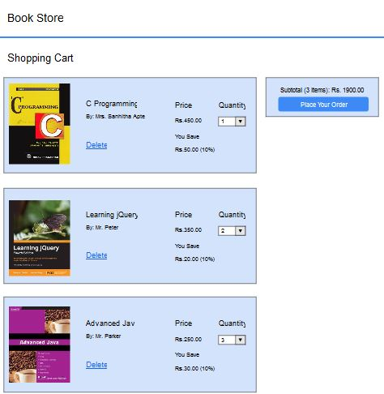
1
2

17.1 User Stories
Id | Label | User Story
1 | Shopping Cart | User should be able to view the all selected items in shopping cart.
2 | Place Your Order | User should be able to process the payment.

17.2 User Interaction Notes
Id | Label | Functional Point
1 | Shopping Cart | - User can access the following menu items  - Home - which directs the user to home page  - About Us - which directs the user to about us page  - Contact Us - which directs the user to contact us page  - Register – which directs the user to registration page  - Login – which directs the user to login page
2 | Place Your Order | - User will be able to view the images in the home page

18.Order
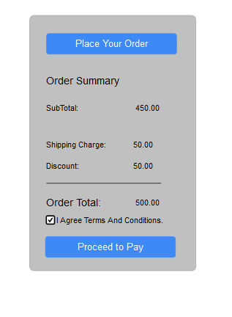
1

2
3

18.1 User Stories
Id | Label | User Story
1 | Place Your Order | Logged-In user should be able to place their order.
2 | Order Summary | Logged-In user should be able to view the order payment details.
3 | Payment Gateway | Logged-In user should be able to proceed for payment.

18.2 User Interaction Notes
Id | Label | Functional Point
1 | Place Your Order | - Logged-In user should be able to place their order that is after viewing the details the user can click on  - Place your order and verify the order payment details
2 | Order Summary | - Logged-In should be able to view the order payment details  - User can view the payment details which includes shipping charges , discounts if any  - The total amount can be viewed after considering all the deductions
3 | Payment Gateway | - Logged-In user should verify the order payment details and then click on accepting the terms and conditions  - The user has to click on accepting the terms and conditions then only the user can proceed to the payment

19.Shipping Address
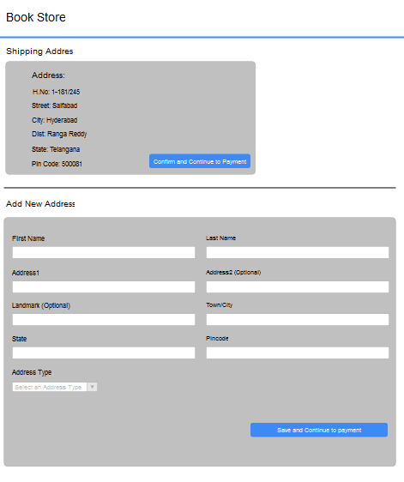
1

3

2

4

5

6

7

8

9

10

11

19.1 User Stories

Id | Label | User Story
1 | Shipping Address | Logged-In user should be able to view their shipping address.
2 | First Name | Logged-In user should be able to enter First name.
3 | Last Name | Logged-In user should be able to enter Last name
4 | Address1 | Logged-In user should be able to enter Address
5 | Address2 | Logged-In user should be able to enter Address
6 | Landmark | Logged-In user should be able to enter Landmark
7 | Town/City | Logged-In user should be able to enter Town/City
8 | State | Logged-In user should be able to enter State
9 | Pincode | Logged-In user should be able to enter Pincode
10 | Address Type | Logged-In user should be able to enter Address type
11 | Save and Continue to payment | Logged-In user should be able to click on save and continue to payment.

19.2 User Interaction Notes
Id | Label | Functional Point
1 | Shipping Address | - Logged-In user should be able to view their shipping address  - The entered shipping address is to be save under user's profile  - so that whenever an user login the shipping address of the corresponding person is obtained
2 | First Name | - Logged-In user should be able to enter the first name  - Validations to be done  - Mandatory  - If not entered alert message – “First name is mandatory”  - Default text – “Enter user’s first name”  - Min length – 3 characters  - Length alert message – “First name must be atleast 3 characters”  - Max length – 20 characters  - Length alert message – “First name must be maximum of 50 characters”  - Valid characters – alphabets and space  - Invalid characters – numbers, other special characters
3 | Last Name | - Logged-In user should be able to enter the last name  - Validations to be done  - Mandatory  - If not entered alert message – “Last name is mandatory”  - Default text – “Enter user’s last name”  - Min length – 3 characters  - Length alert message – “Last name must be atleast 3 characters”  - Max length – 20 characters  - Length alert message – “Last name must be maximum of 50 characters”  - Valid characters – alphabets and space  - Invalid characters – numbers, other special characters
4 | Address1 | - Logged-In user should be able to enter the address  - Validations to be done  - Default text – “Enter user’s street address”  - Min length – 3 characters  - Length alert message – “Street address must be atleast 3 characters in length”  - Max length – 50 characters  - Length alert message – “Street address must be maximum of 50 characters in length”  - Valid characters – alphabets, numbers, space, ‘#’, ‘.’, ‘/’, ‘-‘, ‘&’  - Invalid characters – other special characters
5 | Address2 | - Logged-In user should be able to enter the address  - Optional
6 | Landmark | - Logged-In user should be able to enter the nearest landmark  - Validations to be done  - Default text – “Enter user’s nearest landmark”  - Min length – 3 characters  - Length alert message – “Landmark must be atleast 3 characters in length”  - Max length – 25 characters  - Length alert message – “Landmark must be maximum of 25 characters in length”  - Valid characters – alphabets, numbers, space, ‘#’, ‘.’, ‘/’, ‘-‘, ‘&’  - Invalid characters – other special characters
7 | Town/City | - Logged-In user should be able to enter the Town/City  - Validations to be done  - Mandatory  - If not entered alert message – “City name is mandatory”  - Default text – “Enter user’s city name”  - Min length – 3 characters  - Length alert message – “City must be atleast 3 characters”  - Max length – 25 characters  - Length alert message – “City must be maximum of 25 characters”  - Valid characters – alphabets and space  - Invalid characters – numbers, other special characters
8 | State | - Logged-In user should be able to enter the State  - Validations to be done  - Mandatory  - If not entered alert message – “State/County name is mandatory”  - Default text – “Enter user’s state/county name”  - Min length – 3 characters  - Length alert message – “State/County name must be atleast 3 characters”  - Max length – 25 characters  - Length alert message – “State/County name must be maximum of 25 characters”  - Valid characters – alphabets, space, ‘-’  - Invalid characters – numbers, other special characters
9 | Pincode | - Logged-In user should be able to enter the pincode  - Validations to be done  - Mandatory  - If not entered alert message – “Zip/Post code is mandatory”  - Default text – “Enter user’s zip/post code”  - Min length – 3 characters  - Length alert message – “Zip/Post code must be atleast 3 characters”  - Max length – 25 characters  - Length alert message – “Zip/Post code must be maximum of 25 characters”  - Valid characters – numbers  - Invalid characters – alphabets and all special characters
10 | Address Type | - Logged-In user should be able to selet the type of address  - The Address type may vary as residential address or office address etc
11 | Save and Continue to Payment | - Upon click of the save and continue to payment button  - Success? Then display an alert to the user saying: “User request has been approved successfully”  - Failure? Then display an alert to the user saying: “User request could not be approved. Please try again”

20.Payment
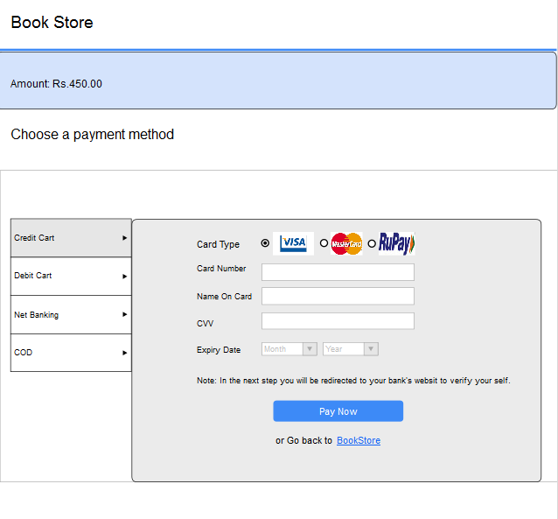
3

1

2

4

5

6

7

8

9

20.1 User Stories
Id | Label | User Story
1 | Total Amount | Logged-in user can view the total amount of the order.
2 | Payment Method | Logged-in user can access or view the payment type to proceed for payment.
3 | Card Type | Logged-In user should be able to enter Card Type
4 | Card Number | Logged-In user should be able to enter Card Number
5 | Name on Card | Logged-In user should be able to enter Name on Card
6 | CVV | Logged-In user should be able to enter CVV
7 | Expiry Date | Logged-In user should be able to enter Expiry Date
8 | Pay Now | Logged-In user should be able to click on Pay Now
9 | Go back to BookStore | Logged-In user should be able to click on Go back to BookStore

20.2 User Interaction Notes
Id | Label | Functional Point
1 | Total Amount | - User can view the total amount for the ordered products
2 | Payment Method | - User can select the type of payment that is used to proceed to payment
3 | Card Type | - User has to enter the type of card for payment
4 | Card Number | - User has to enter the card number to proceed for payment
5 | Name on Card | - User has to enter the name on the card to proceed to payment
6 | CVV | - User has to enter a valid CVV number to proceed to payment
7 | Expiry Date | - User has to enter the expiry daet that is on the card
8 | Pay Now | - User can click on pay now button after enterring all the card details  - After clicking on the pay now button the user is directed to bank web server
9 | Go back to  BookStore | - User can click on Go back to BookStore so that the user is redirected to the bookstore page  - The user can use this button if the user doesn't want to proceed to payment

21.Your Orders
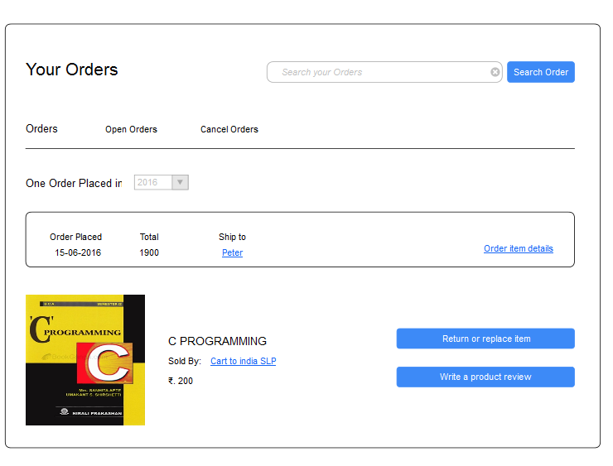
1
2

4

3

21.1 User Stories
Id | Label | User Story
1 | Search | Logged-In user should be able to view the search bar.
2 | Order Details | Logged-In user should be able to view the order details of the searched order.
3 | Image | Logged-In user should be able to view the image of the ordered product.
4 | Product review | Logged-in user should be able to view the review tab of the product.

21.2 User Interaction Notes
Id | Label | Functional Point
1 | Search | - Logged-In user should be able to view the search tab in order to search the placed orders  - Logged-In should can enter the user's search criteria to view the result.
2 | Order details | - Logged-In user can view the details of the order with the search results  - Logged-In user can view the item details of the orders that are placed  - Logged-In user can view the previous ordered products by selecting date depending upon the search criteria
3 | Image | - Logged-In user should be able to view the image of the order selected and details of the order  - Whenever logged-in user changes the search criteria the image also changes with that of the selected product
4 | Product Review | - Logged-In user after viewing the order details can select either of the options as  - Return or replace item – the user can return the order or can replace the item with a new one  - Write a product review – if the user is satisfied with the product the user can write a review about that product

22.Order Item
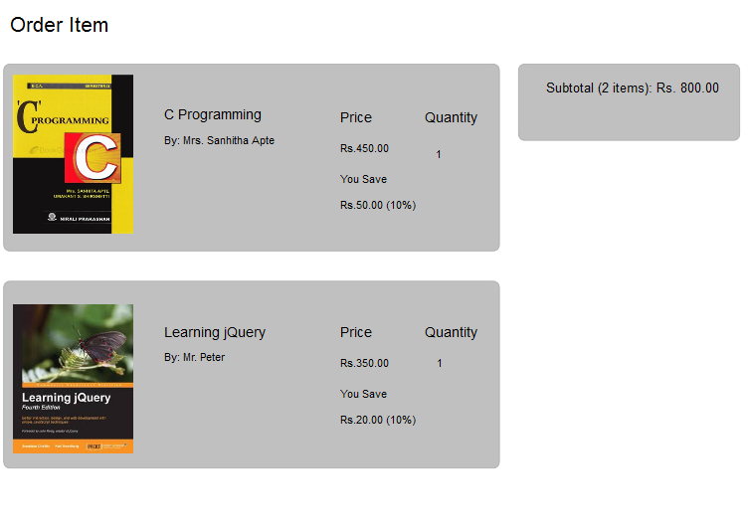
1
2

22.1 User Stories
Id | Label | User Story
1 | Order Item | Logged-In user will be able to view the details of the order.
2 | Price | Logged-In user will be able to view the price details of the order.

22.2 User Interaction Notes
Id | Label | Functional Point
1 | Order Item | - User can view the details of the order  - Order may contain many number of items , so the user can view all the items that are contained in that order
2 | Price | - User can view the price of that selected order  - User can know the number of sub items that are contained in that order and followed by the total price of that order

23.Order Item Details

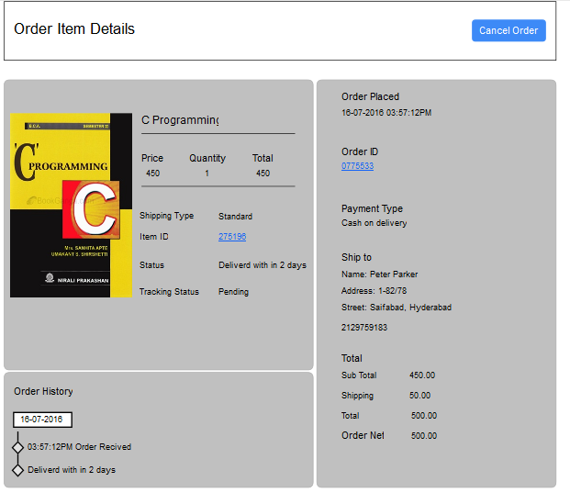
1
2

3

23.1 User Stories
Id | Label | User Story
1 | Order Item | Logged-In user will be able to view the details of the item.
2 | Price | Logged-In user will be able to view the price details of the items that are ordered.
3 | Cancel Order | Logged-In user can view the cancel orders button.

23.2 User Interaction Notes
Id | Label | Functional Point
1 | Order Item | - User can view the details of the items  - User an verify the item details which include:  - Quantity  - Price  - Total Cost  - Shipping Id  - Status  - Item Id  - User can also check the order history for the selected item
2 | Price | - User can view the price of that selected item.  - User can view the following:  When the order is placed  - Order Id  - Payment Type  - Shipping Address  - Price  - Shipping Cost  - Total Price
3 | Cancel Order | - User can view the cancel order button  - If the user doesn't want to take the items the user can cancel the items that are in the order  - User can select and cancel the items individually

